battlefield of the future
- Avi Belizovsky
- March 18, 2022
This is what Zvi Or-Bach, CEO of MonolithIC 3D, fears following an article by Alibaba engineers that shows that they were able to accelerate AI applications a thousand times using chips in old technologies * In an interview we explained that the miracle was done different
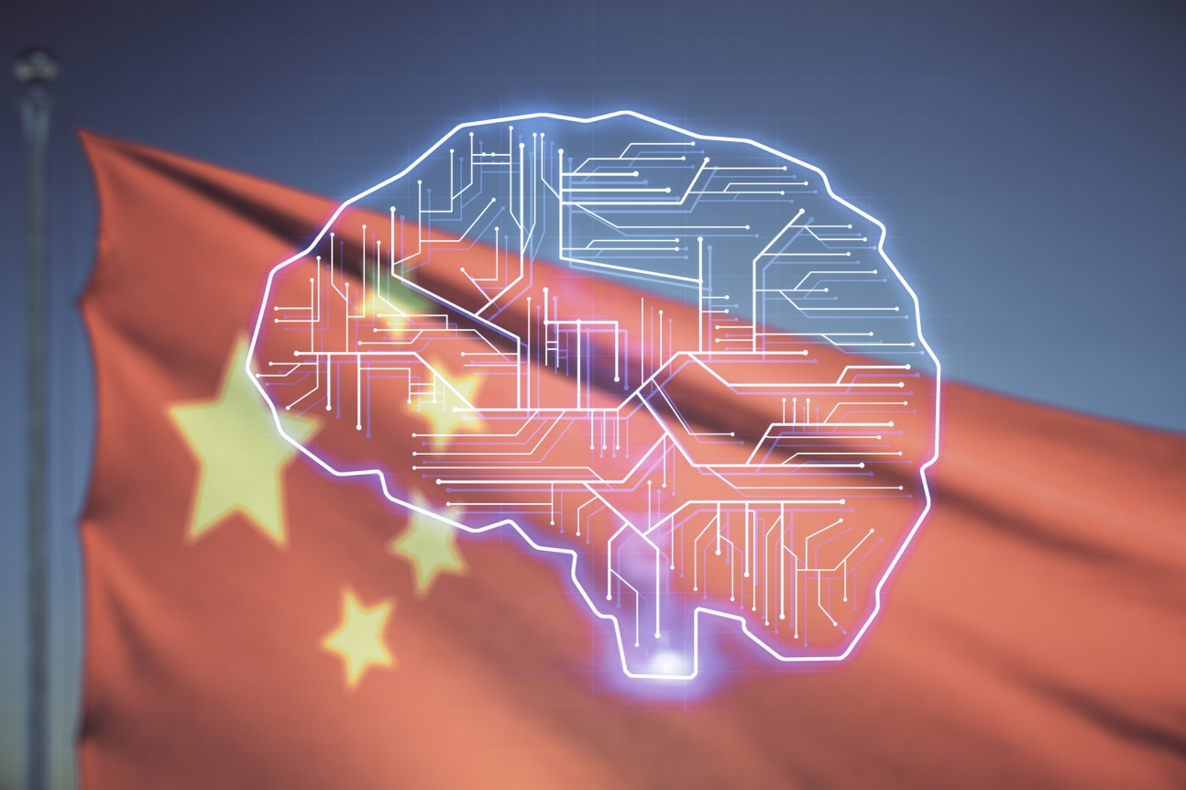Will China dominate the field of artificial intelligence? Illustration: depositphotos.com
China may win in the field of artificial intelligence computing which is the battlefield of the future. So says Zvi Or-Bach, MonolithIC 3D: In an interview with CHIPORTAL following an article he wrote in the professional press in which he warns that if the West does not recover, China will use its advantage in AI as a weapon to subdue the West.
Explore the knowledge

He cites an article published at the 2022 IEEE International Solid-State Circuits Conference in which researchers working at Alibaba (ALIBABA # NASDAQ: BABA) write that they used a 55 nm chip but were able to greatly improve artificial intelligence performance over Intel's only 14 nm processor. By laying the memory above the processor and connecting a hybrid between them. "If indeed the things written in the article are true, then they will reach supremacy in the field of artificial intelligence, and this is the medium in which the next war will actually take place."
Or-Bach quotes Applied Materials CEO Gary Dickerson as saying: “The technological engine of the next ten years is artificial intelligence. Are we ready for the greatest opportunity of our lives? ” Dickerson travels the world talking to chip makers and policymakers about a $ 10 trillion question: How do we capture the economic opportunity of artificial intelligence, which will change almost every industry and institution in the coming years? In fact, artificial intelligence is a moving target because computing requirements are doubling every three and a half months. ”
In a conversation with the Scientist website and the Chiportal website, Or-Bach explains: “In the future war, whoever has a stronger AI will win. If the differences are huge as the article shows can be a big problem for all of us I do not know how much the Chinese have progressed beyond the article and moved towards a more applied direction but I do know to say that the article shows a thousand times advantage in AI performance. And all this was done with a 55 nm chip versus a 14 nm chip. If this work is just the tip of the iceberg (because the Chinese rarely publish), if we do not move quickly, we will all be Chinese slaves. ”
The Chinese approached the problem in a completely different way and with a different three-dimensional architecture. In 2017 I spoke at the ChipEx conference and warned about the possibility of increasing chip performance a thousand times in AI applications through the use of 3D architecture. The Chinese achievement is not accidental, it is as real as we foresaw five years ago and if the West does not recover we may find ourselves at a disadvantage in the field of artificial intelligence that will be difficult to catch up with. "

The death of Moore's Law
“To date there has not been a strong enough reason to replace the traditional method of chip production, because according to Moore's Law, each generation provides a 30% improvement in performance. But in recent years there has been talk that Moore's law will slow down if not stopped altogether. The Chinese also have another problem, because the West prevents them from using even the most advanced chips that already exist, so they went for 3D and got a performance improvement of not 30% but a thousand times in AI performance, and I can say that this is just the beginning. " Says Or-Bach.
“There are other ways to improve chip performance that are not just reducing the junction as has been the case so far with Moore’s Law. Just to clear the ear, all the electronic circuits in the world are made up of a combination of conductors - metal wires and transistors. In the field of transistors we have improved a million times in accordance with Moore's law. The metal wires did not improve. On the contrary, the smaller they are the less good they are. Smart design can compensate a bit for the quality of the wires but over time it is impossible to compensate for the wires. This is even more true when it comes to memory. ”
“Today we work with two chips, a processor and a memory, that connect via a board and the information comes from one chip to the other through the I / O components of each of them. This situation greatly limits future connectivity and in fact the pace of improving computing performance. Once Alibaba took a processor chip from one factory and named it a memory chip from a second factory and placed it on top of the first talking about a density of 100,000 wires per square millimeter. It is a larger connection of magnitude between logic and memory than can be done in the way we have worked in it to date, ie in the integration of two chips separately. ”
According to Or-Bach, he is making souls of this insight among the computer industry in the world and in Israel in particular. I still believe that Israel can lead in the field of artificial intelligence because it is a matter of architecture and not of production TSMC will produce what we ask of it. The country has all the knowledge needed to lead but I have not been able to generate momentum. I met with the chief scientist (now the Innovation Authority) and others but it did not help.
Can you give an example of using AI as a weapon?
"The future war will not be like the wars of the past. The war at the moment is completely primitive. An example of this is a squad of skimmers that will operate autonomously and do whatever we ask of them without operating tanks. An example of this is the long line of Russian tanks moving slowly. This is because the Ukrainians have a superiority in the field of drones. They have purchased a Turkish UAV and they are eliminating any Russian armor or tank they see. Today these are individual gliders that are operated remotely but if it is possible to lift a lot of gliders and control them using AI it will be possible to hit locally anyone who wants to. It's all a matter of control and computing forces that if you are strong in them you can not be stopped. As I mentioned in subsequent wars the winners will be those who have an advantage in the field of artificial intelligence, especially if the difference is significant, and if we do not do it someone else will do it, which is not always a good thing. ” Or-Bach concludes.
In recent years, tensions have been growing in US-China relations, with the result that the US is preventing China from accessing advanced technologies and equipment for chip production. (A process that has also been repeated against the Russians, in recent weeks due to the invasion of Ukraine) This includes access to advanced tools such as EUV lithography. Accordingly, it was reported that only TSMC, Samsung and Intel remained in the race at technology nodes less than 10 nm in size. It therefore makes sense for Chinese companies to focus alternative resources on mature chip technologies, analysts say.
This could explain the adoption of hybrid linkage as a core technology by many Chinese companies. Hybrid linkage allows them to replace the dimensional magnification of the nodes with a three-dimensional magnification at the system level.
In August 2018 YMTC officially launched its groundbreaking Xtacking architecture at the pinnacle of flash memory and won the “Best in Exhibition” award. In its 3D NAND product, it uses two chip production lines, one for the 3D NAND multilayer memory and one for the peripheral circuits (memory control).
In September 2020 another Chinese company, IC League, published the results of its heterogeneous on-chip integration technology (HITOC), the development of an artificial intelligence-oriented chip, in an article entitled "Breaking the Memory Wall of Artificial Intelligence Chips with a New Dimension".
And as stated in the present article it appears that the Chinese (in this case Alibaba engineers) were able to increase the performance of existing chips only by laying the memory above the processor in what is called a three-dimensional chip.
From the article: “At HITOC, we have two slices, a logical slice and a memory slice, attached together (using a hybrid link). In the logical slice, there are repositories of processing units. Below this logical database in the second slice are databases of DRAM arrays ”. The results reported by IC League were an overall improvement in orders of magnitude. At ISSCC 2022 Alibaba presented in the article an improvement of more than a thousand times in artificial intelligence computing devices that use hybrid linkage.
“This article presents a very important breakthrough in performance and power reduction. Alibaba researchers explain that “Compared to the traditional CPU-DRAM system, our chip (Alibaba) achieves a speed of 9.78 × (i.e. almost 10 times, AB). They emphasize that memory throughput and capacity can be further enhanced by increasing the number of hybrid connection blocks or using more advanced process technologies to serve more sophisticated recommendation models. ”
In terms of energy efficiency, which is significant in memory-related applications, our work achieves 184.11QPS / W (QPS - Queries per Second), which exceeds the CPU-DRAM system by 317.43 ×. In terms of space efficiency, high-density hybrid adhesion improves QPS / mm2 by 660 ×. ” The results were obtained using a relatively old 55-nanometer process node for the logic and compared to the leading 14-nanometer Intel Xeon Gold processor.

